I 1111111111111111 1111111111 1111111111 11111 1111111111 111111111111111 11111111
US010111783Bl

c12) United States Patent
(10) Patent No.:
US 10,111,783 Bl

Dellinger
(45) Date of Patent:

Oct. 30, 2018

(54) SILICA FIBER COMPOSITION AND METHOD OF USE

- Applicant: American Nano, LLC, Clemmons, NC
(US)

- Inventor: Mitch Dellinger, Clemmons, NC (US)
(58) Field of Classification Search
CPC A61F 13/00017; A61F 2013/00787; C07F
7/025; D0lD 5/0015; C0lB 33/126; C0lB 33/14; C0lB 33/146; C0lB 33/148;
C0lB 33/157; C0lB 33/158
See application file for complete search history.

- Assignee: American Nano, LLC, Clemmons, NC
(US)
(56)
References Cited
U.S. PATENT DOCUMENTS

( *) Notice:

Subject to any disclaimer, the term ofthis patent is extended or adjusted under 35
U.S.C. 154(b) by 0 days.
8,088,965 B2
8,512,741 B2
8,647,557 B2
9,554,463 B2
2012/0244292 Al
1/2012 Thierauf 8/2013 Tan
2/2014 Yeo
1/2017 Sethumadhavan 9/2012 Lee

- Appl. No.: 15/934,599 (Continued)

- Filed:

Mar. 23, 2018

Related U.S. Application Data

FOREIGN PATENT DOCUMENTS
CN 102652903 A * 9/2012
WO 2017186201 11/2017

(60)

(51)
Provisional application No. 62/710,305, filed on Feb. 16, 2018, provisional application No. 62/643,946,
filed on Mar. 16, 2018.

Int. Cl.

OTHER PUBLICATIONS
Choi, et al., "Silica Nanofibers From Electrospinning/Sol-Gel Pro­ cess," Journal of Materials Science Letters 22, 2003, 891-893.

(52)
A61F 13/00 C0JB 331157 C0JB 33/148 C0JB 33/146 C0JB 331158
C0JB 33112
C07F 7102
D0JD 5100
U.S. Cl.
(2006.01)
(2006.01)
(2006.01)
(2006.01)
(2006.01)
(2006.01)
(2006.01)
(2006.01)
(Continued)

Primary Examiner - Anthony J Zimmer
- Attorney, Agent, or Firm - Morgan, Lewis & Bockius LLP

(57) ABSTRACT
Embodiments of the invention include methods for making silica fiber mats useful for treatment of animal wounds and

CPC A61F 13/00017 (2013.01); C0JB 33/126
(2013.01); C0JB 33/146 (2013.01); C0JB
33/148 (2013.01); C0JB 331157 (2013.01);
C0JB 331158 (2013.01); C07F 71025
(2013.01); D0JD 510015 (2013.01); A61F
2013/00787 (2013.01)
tissue, as well as for other applications in industry. The fiber mats are formed via electrospinning of a sol gel produced with a silicon alkoxide reagent, such as tetraethyl ortho silicate, alcohol solvent, and an acid catalyst.

29 Claims, 12 Drawing Sheets

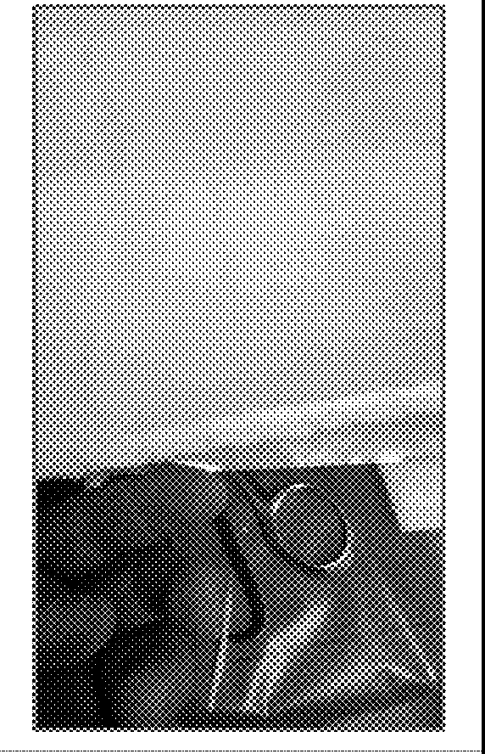

US 10,111,783 Bl
Page 2

(56) References Cited
U.S. PATENT DOCUMENTS

2013/0115186 Al 5/2013 Baecker

OTHER PUBLICATIONS
Geltmeyer, et al., "The Influence of Tetraethoxysilane Sol Prepa­ ration on the Electrospinning of Silica Nanofibers," J Sol-Gel Sci Technol (2016) 77:453-462.
Milea et al., The Influence of Parameters in Silica Sol-Gel Process,
Bulletin of the Transilvania University of BraS ov Series I: Engi­ neering Sciences• vol. 4 (53) No. 1-2011.
Sakka et al., "The Sol-Gel Transition in the Hydrolysis of Metal Alkoxides in Relation to the Formation of Glass Fibers and Films," Journal of Non-Crystalhne Solids 48 (1982) 31-46.

* cited by examiner

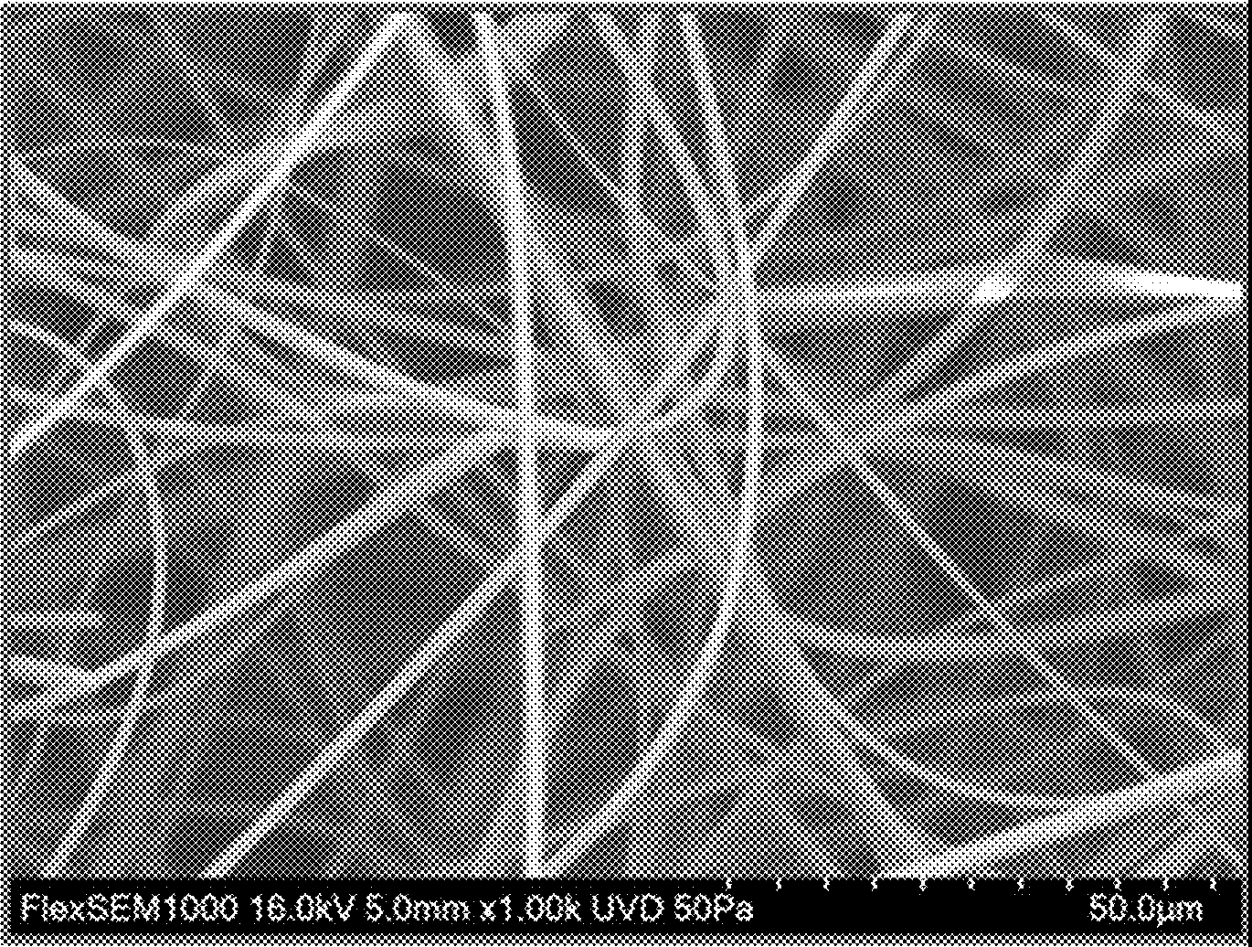
FIG lA

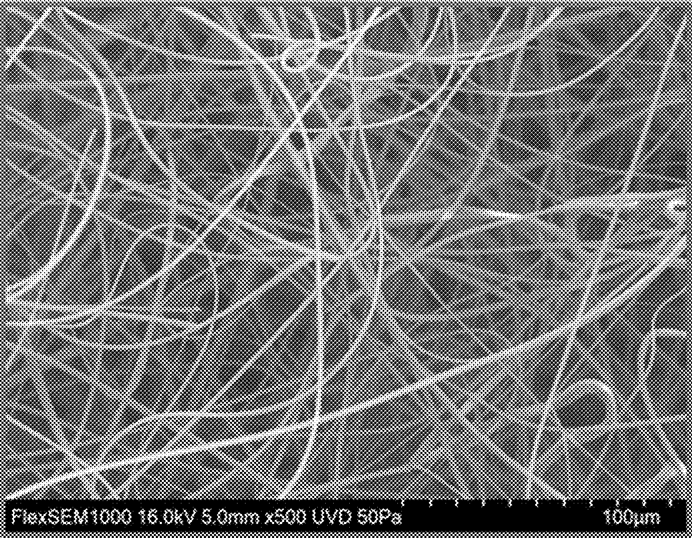
FIG 18

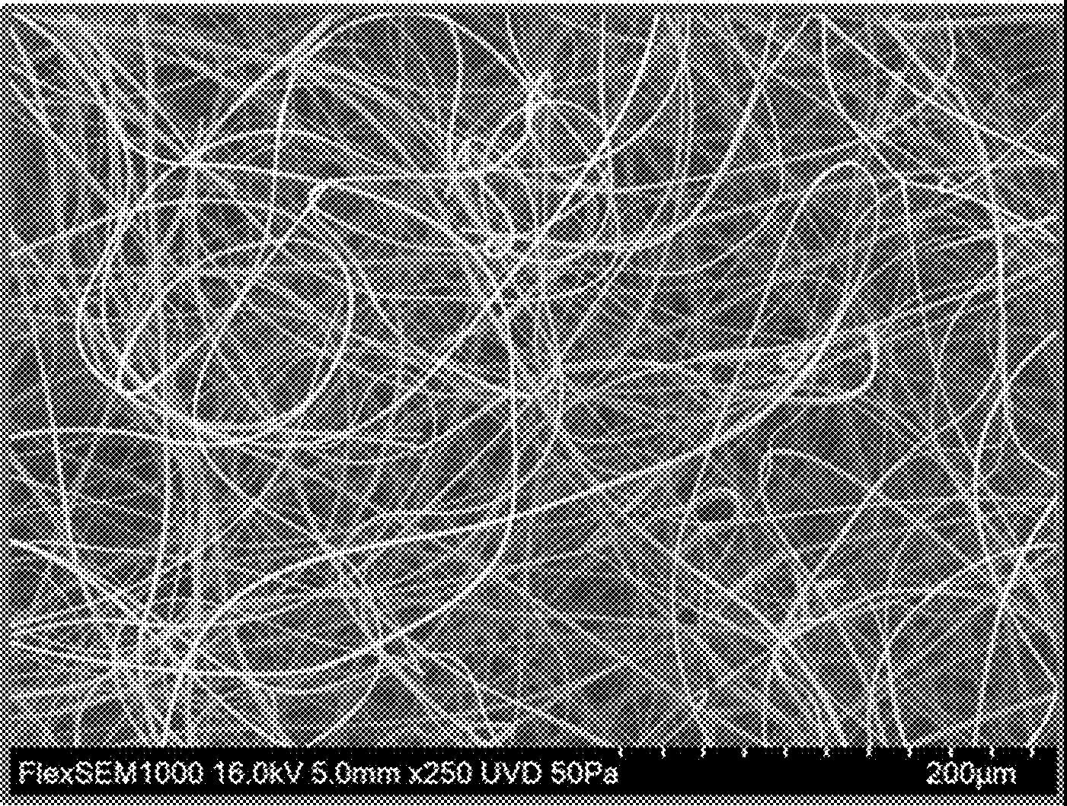
FIG lC

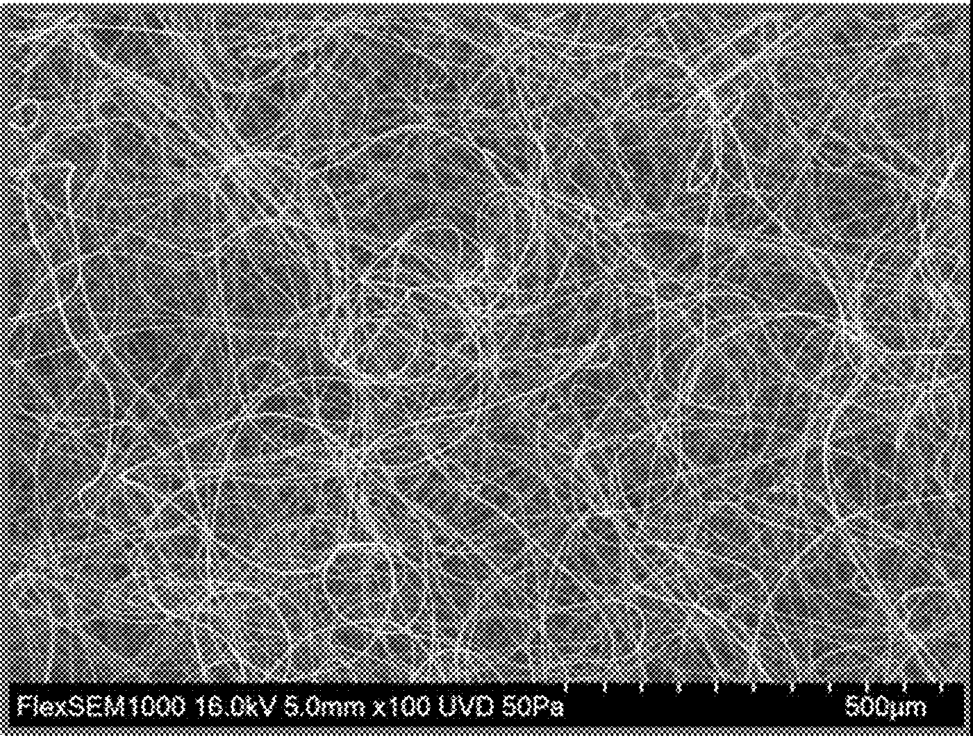
FIG 1D

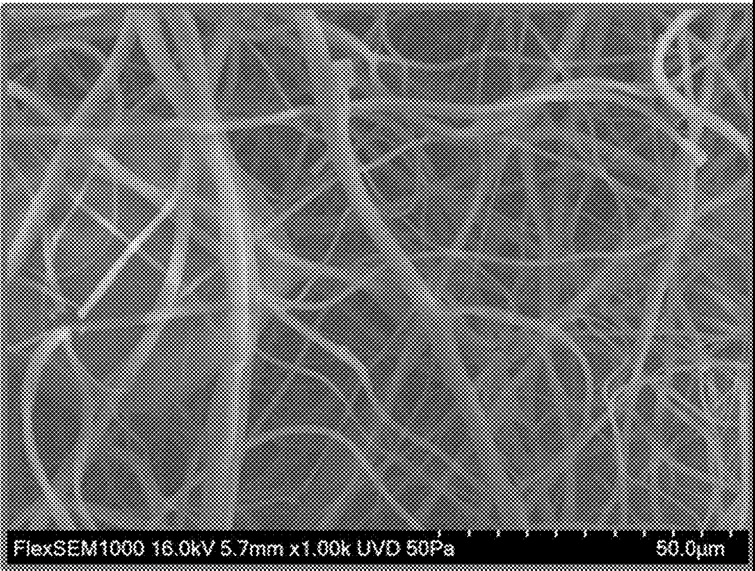
FIG 2A

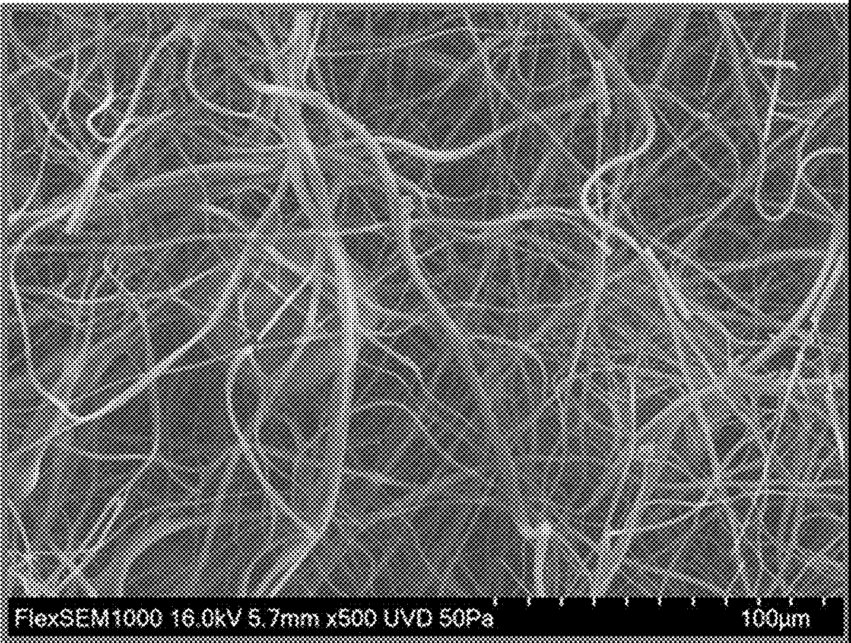
FIG 2B

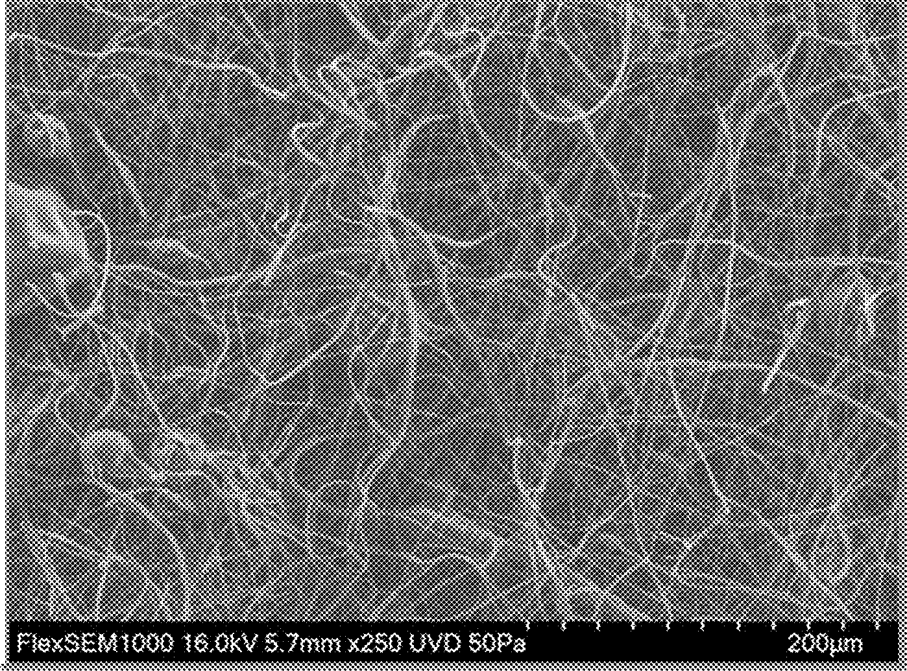
F1G 2C :··············································································································································································

I

FIG 20
ll

I
i

I

I
,l.l

ll
=
I
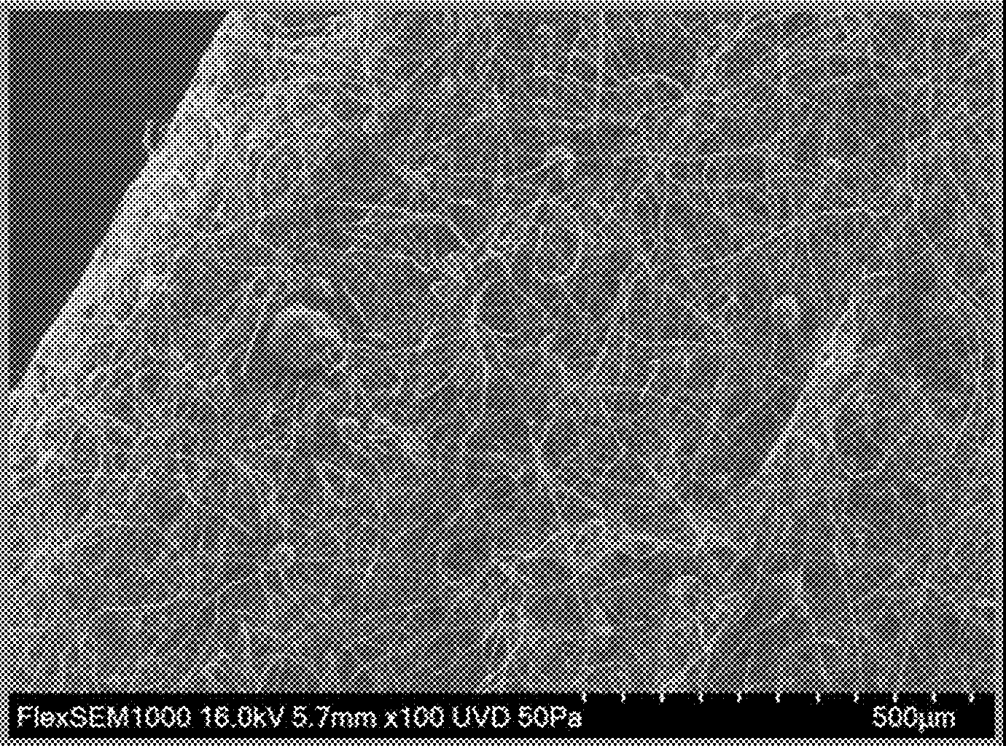
i

FIG. 3

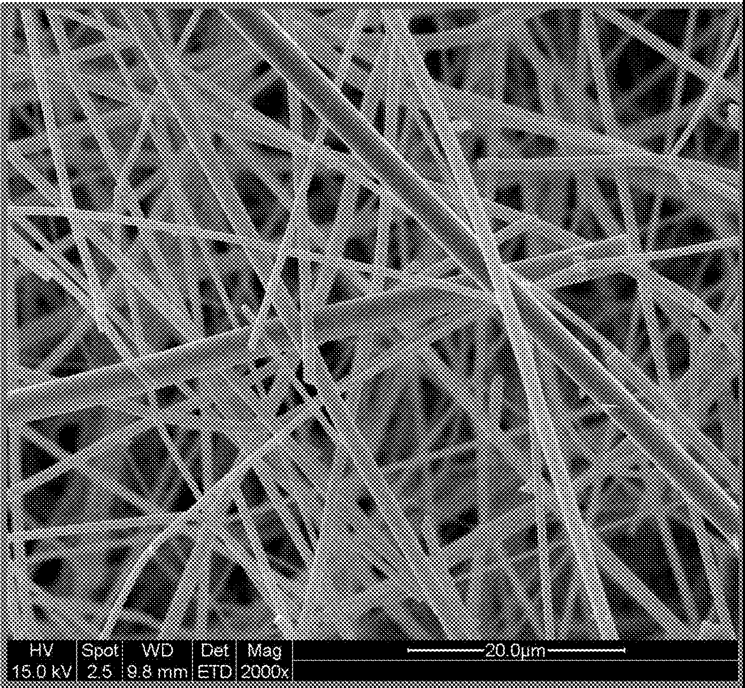

FIG.4

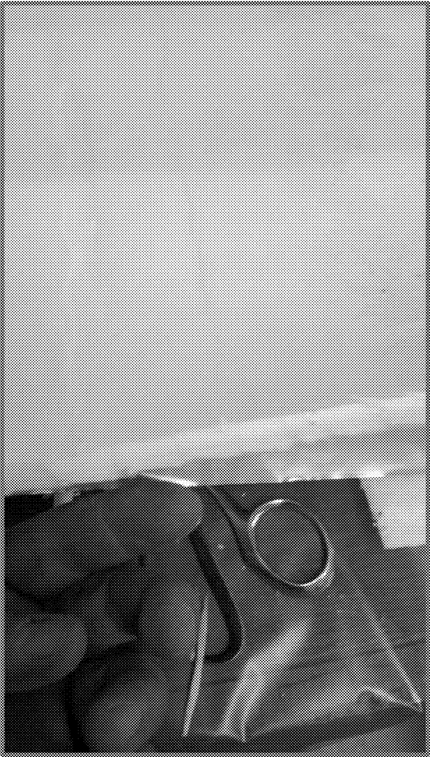

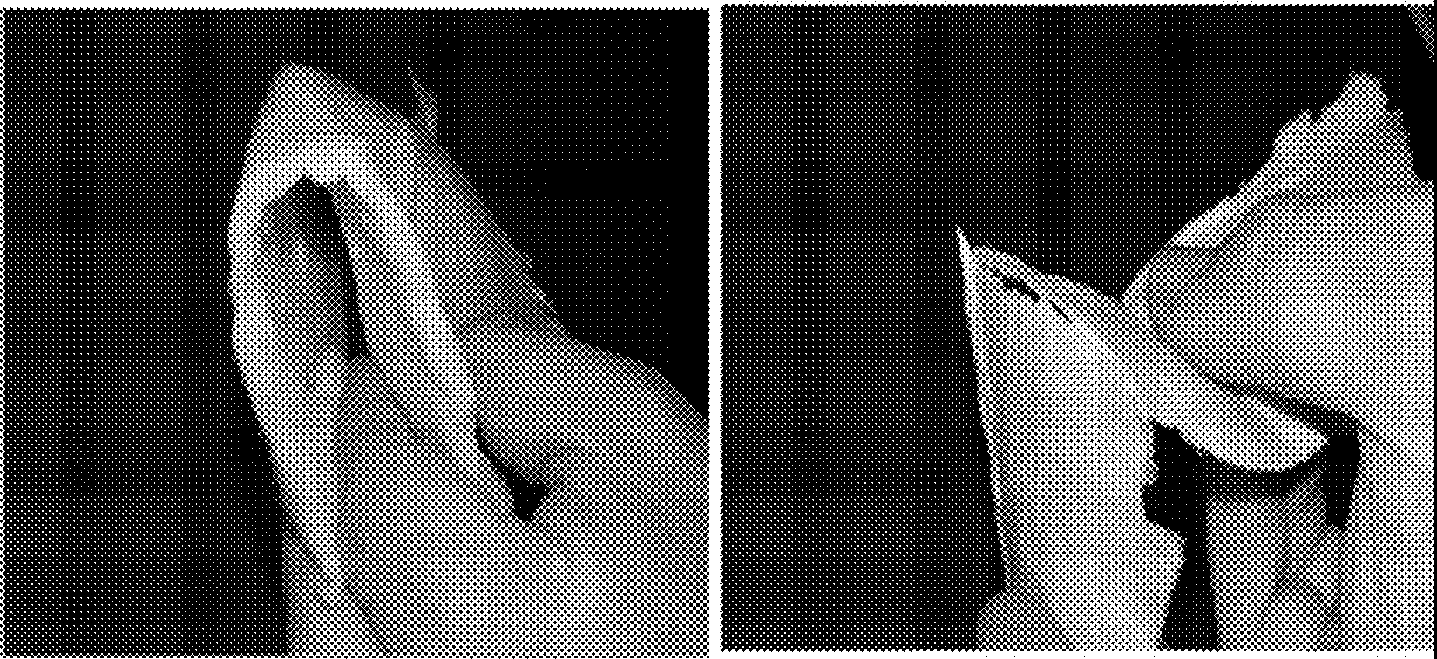
FIG SA FIG 5B

FIG. 6

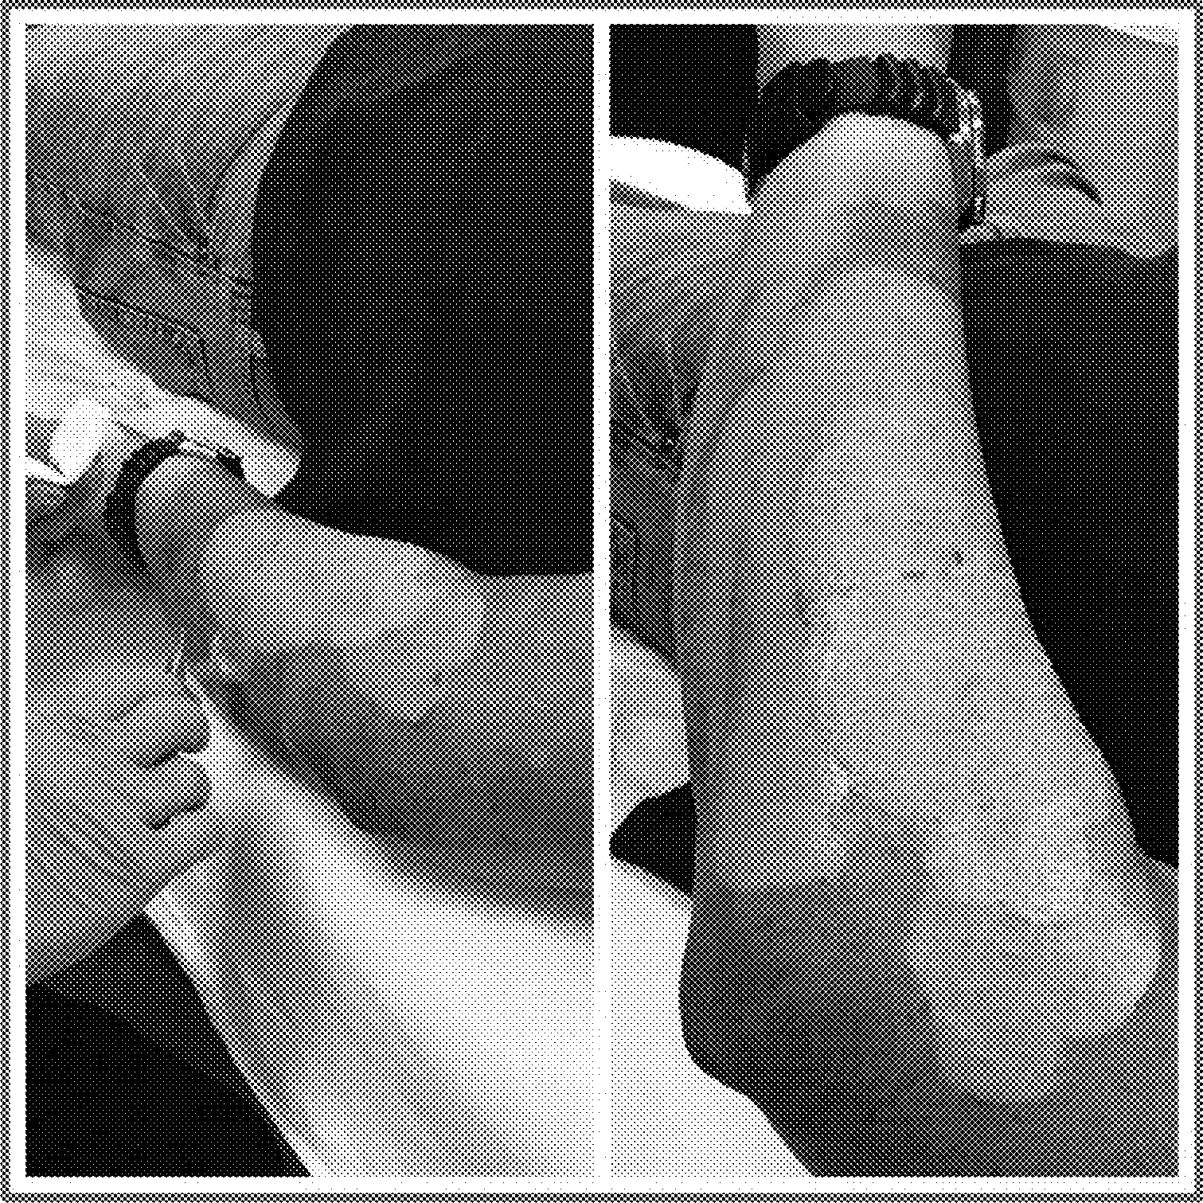

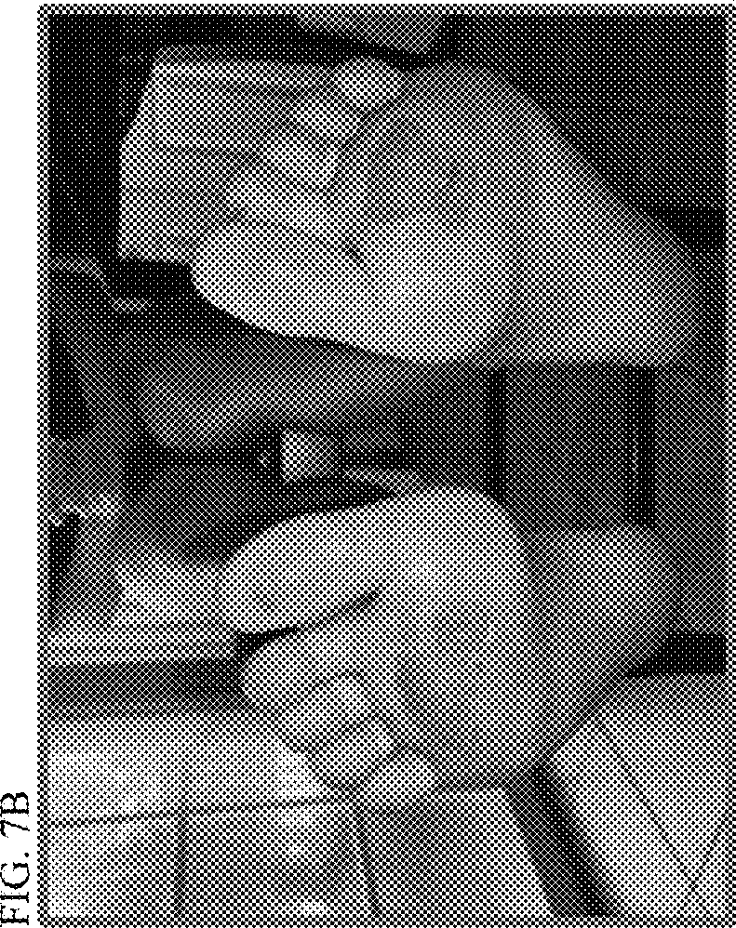
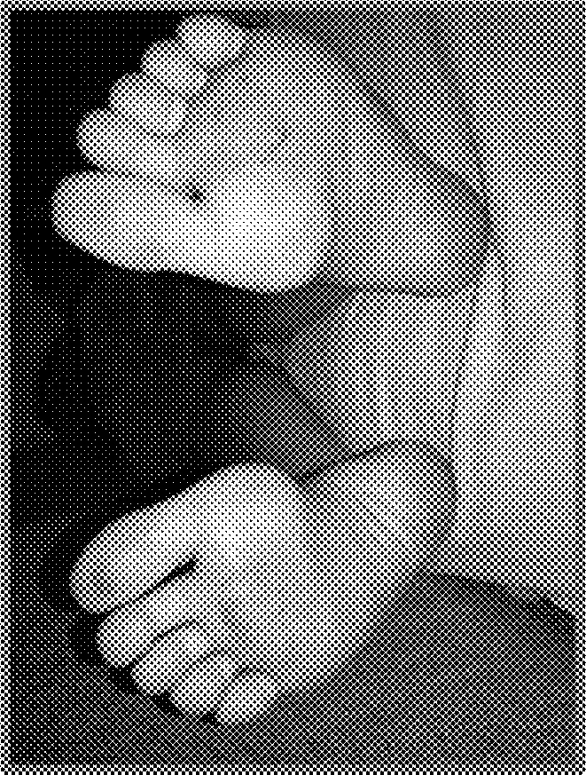
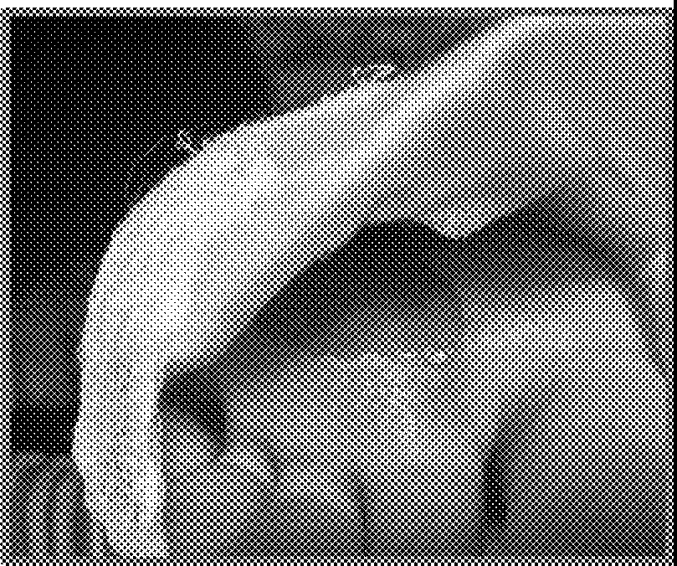
<r---
ru---
ci
µ..
,-;
0,. ,
µ.,

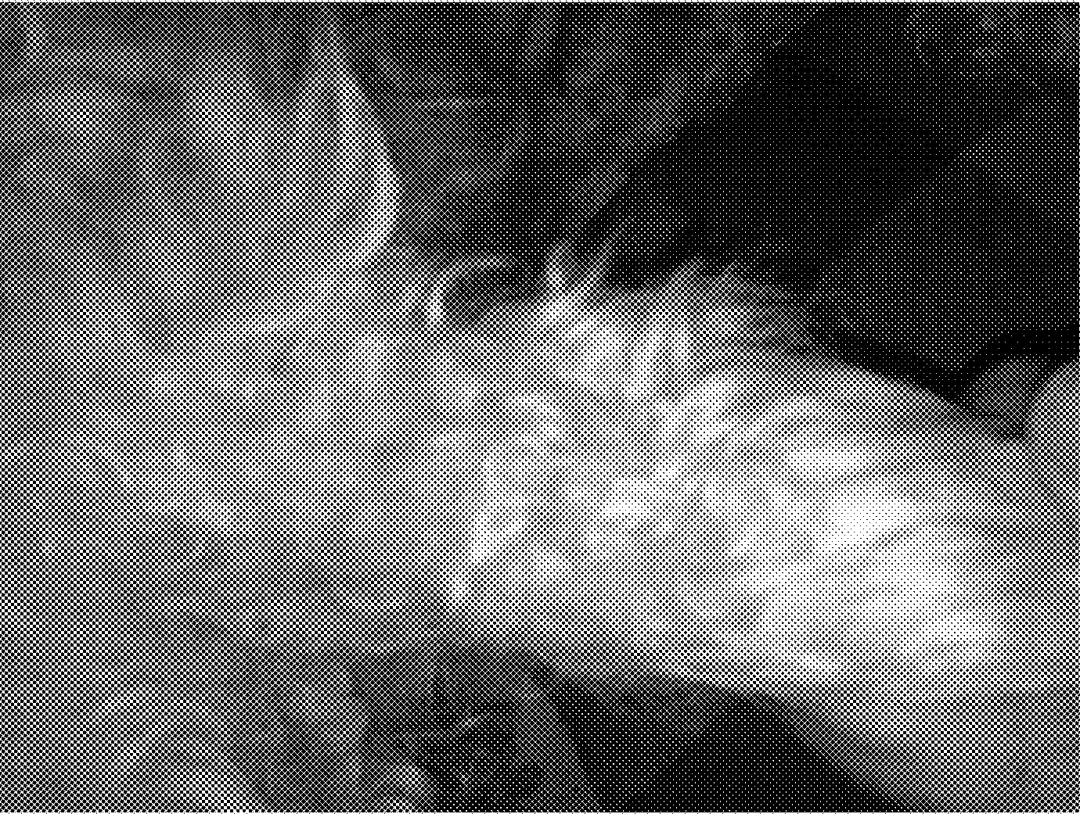
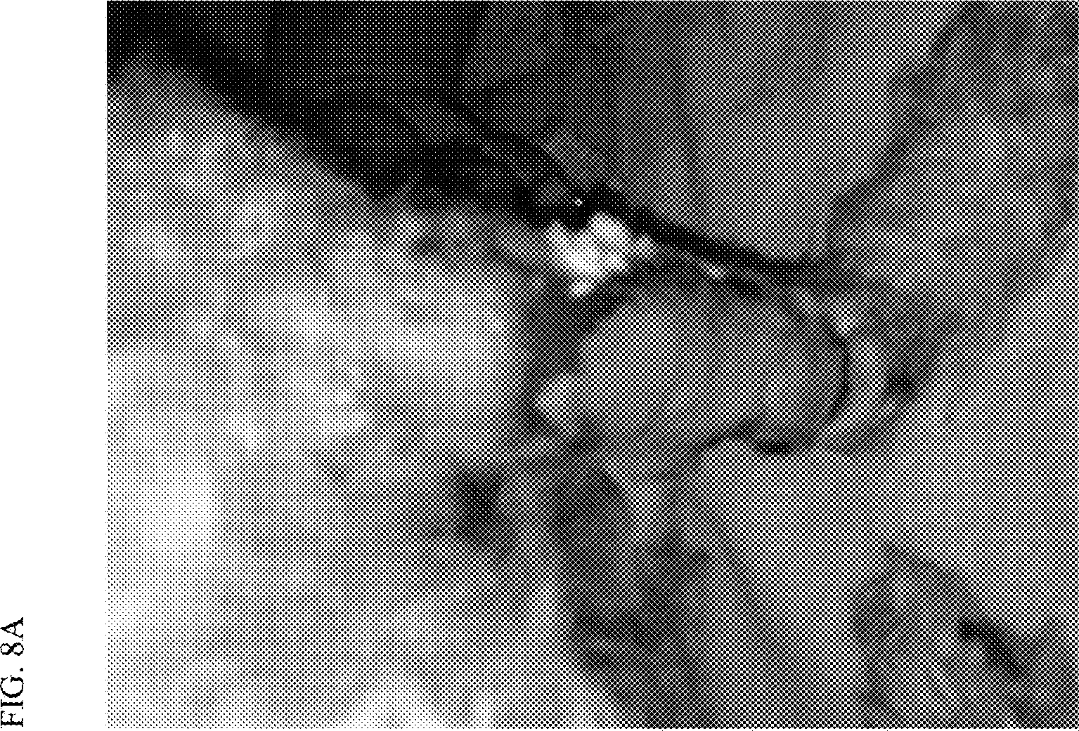

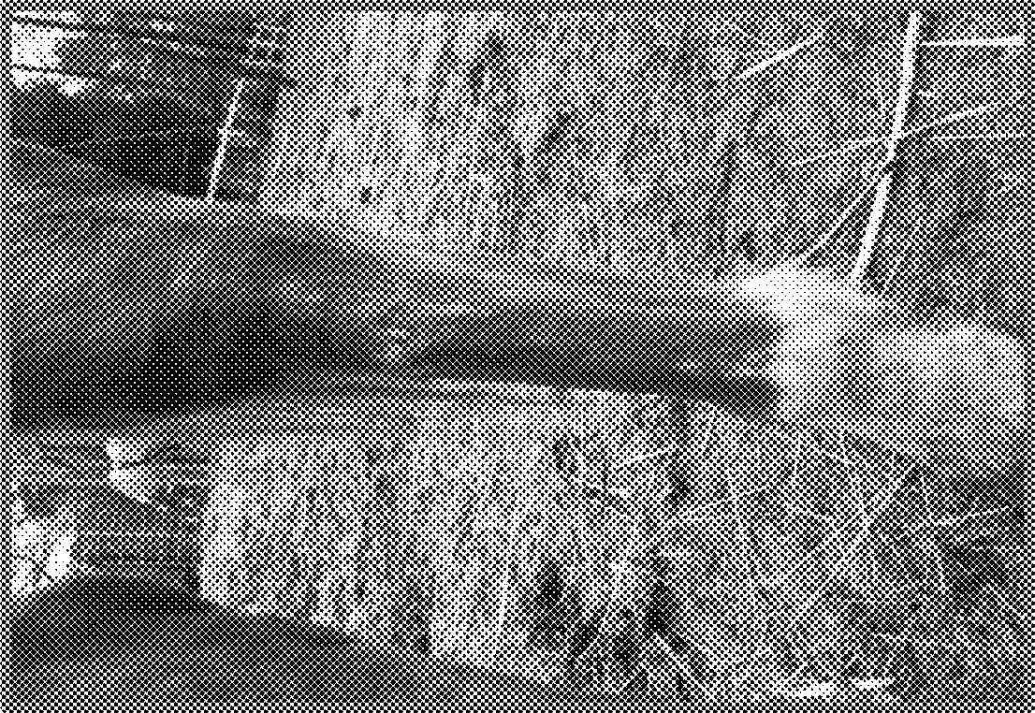

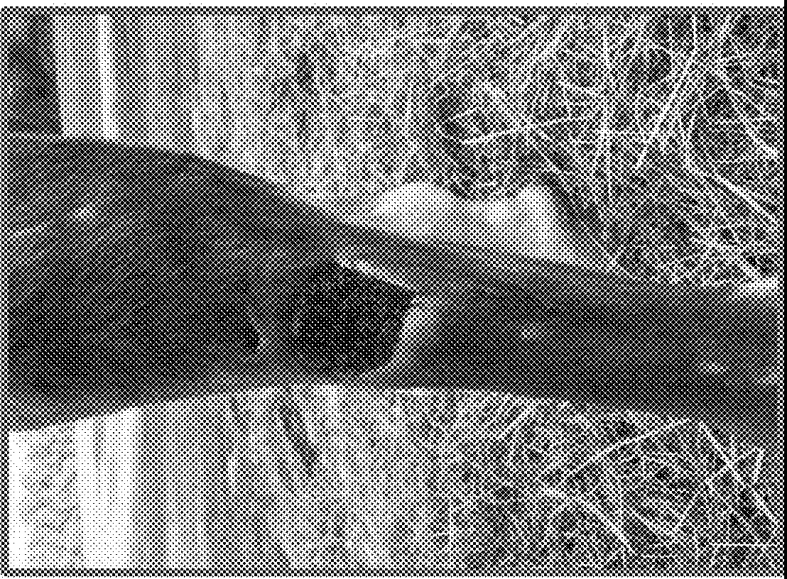
co
°'
S2
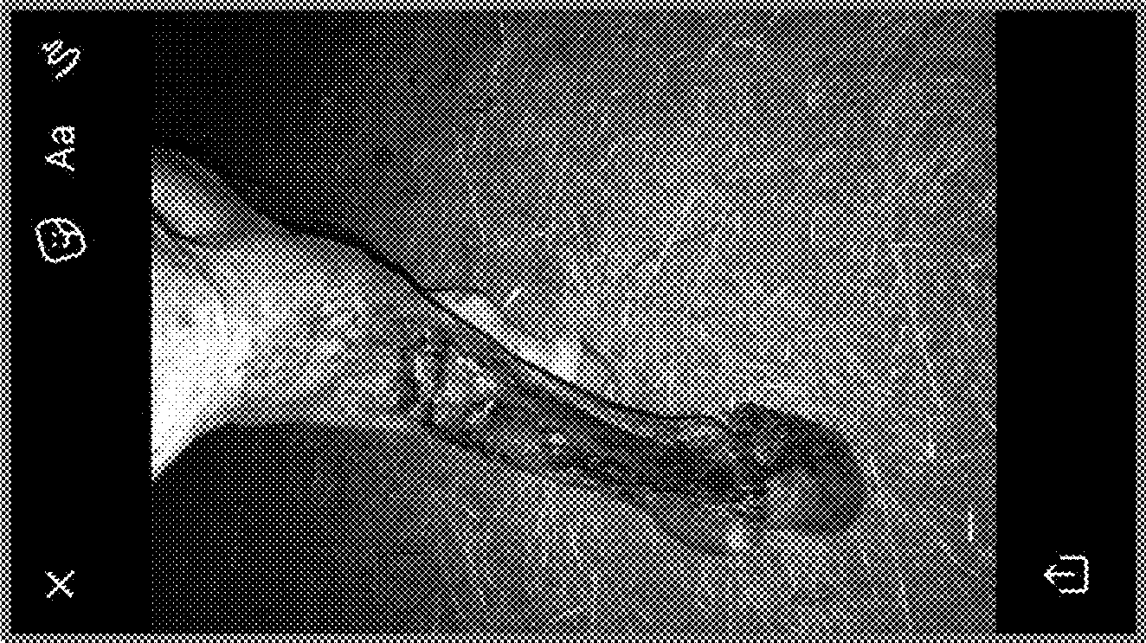
r.i...

0
-
r.i...

co
0
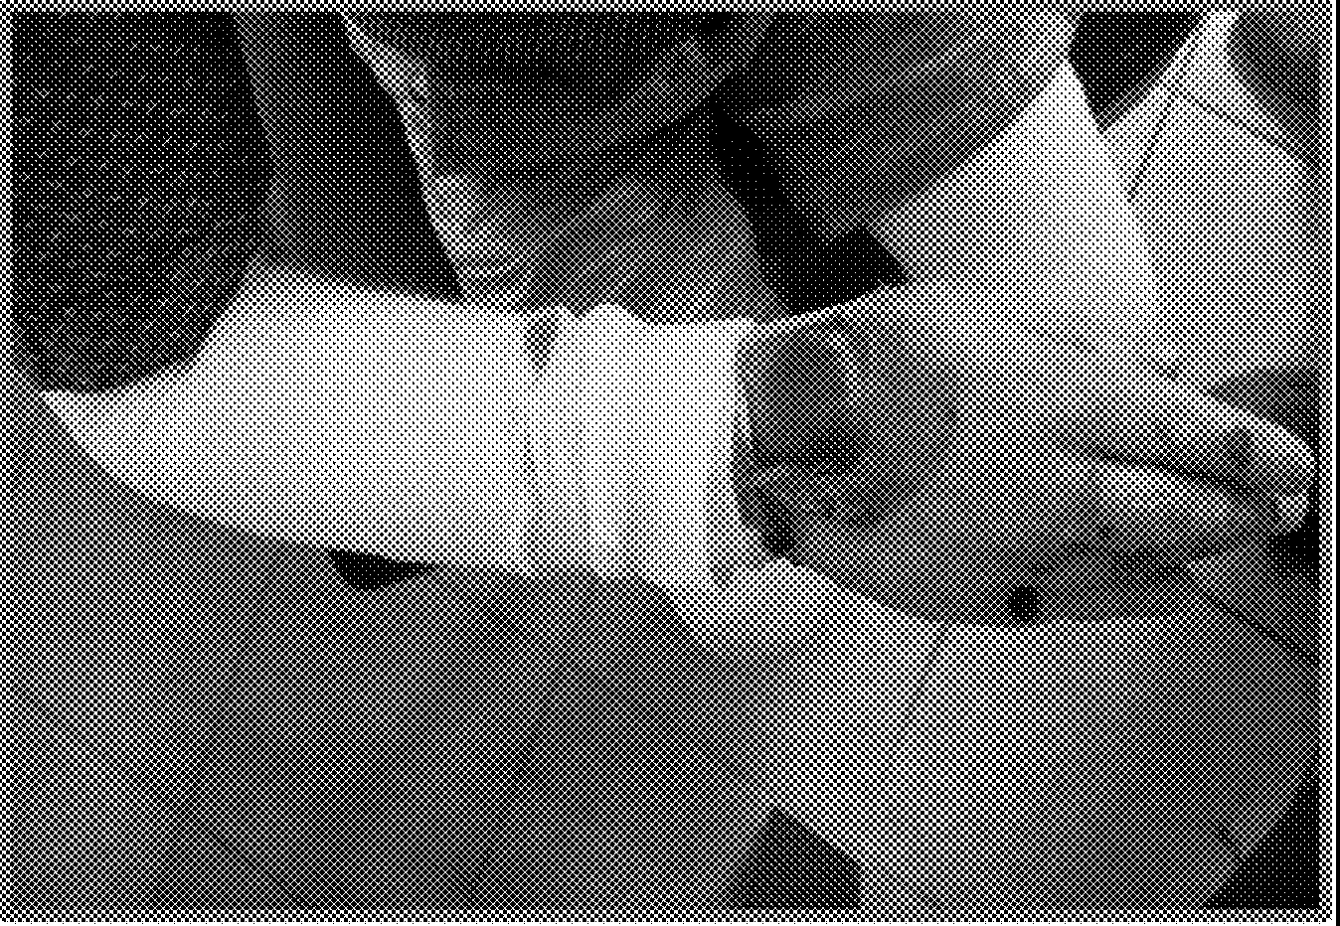
,...;

0,.....

SILICA FIBER COMPOSITION AND METHOD OF USE

PRIORITY

This Application claims the benefit of U.S. Provisional Application No. 62/710,305 filed Feb. 16, 2018, and U.S. Provisional Application No. 62/643,946 filed Mar. 16, 2018, which are hereby incorporated by reference in their entire­ ties.

BACKGROUND

Wound healing involves a well-coordinated series of
paring a sol with a silicon alkoxide reagent, such as tetra­ ethyl ortho silicate (TEOS), alcohol solvent, and an acid catalyst, and transitioning the sol for at least 2 days and less than 7 days under conditions where humidity and tempera-
s ture are controlled. The sol-gel is electrospun to create a
silica fiber mat with superior texture and properties.
In some embodiments, the composition is a lightweight structure composed of silica fiber (e.g., silicon dioxide nanofiber). By ripening ("transitioning") the sol under con-
10 trolled environmental conditions, and/or monitoring the properties of the sol during the ripening/transitioning pro­ cess, the relatively short window to successfully electrospin the sol-gel can be identified to prepare a superior composi- tion for wound care and other applications.

biological processes that include both tissue destruction and 15 tissue regeneration. For example, during normal wound healing, neutrophils and monocytes are recruited to the wound during an early inflanmiatory phase. The neutrophils phagocytize debris and micro-organisms; monocytes and
In various aspects, the present invention provides com- positions and methods for improving integrity of injured tissue in a subject, including for accelerating or improving healing of acute or chronic wounds. The compositions comprise a silica fiber matrix, which is applied to injured

other cells release enzymes in the surrounding matrix to digest damaged tissue. Fibrin is broken down as part of this process, and the degradation products attract fibroblasts and epithelial cells to the site of the wound. Macrophages recruited to the wound (as well as other cells) secrete
20 tissue to support tissue regeneration and healing. In some
embodiments, the silica fiber matrix is a non-biodegradable scaffold that is not removed from the wound (unlike a conventional wound dressing), but becomes integrated with the regenerated tissue.

extracellular enzymes that act on all components of the 25 extracellular matrix and are responsible for removal of devitalized tissue. Macrophages also secrete a variety of cytokines and growth factors that can stimulate keratino­ cytes, fibroblasts and angiogenesis, which promotes the
In accordance with embodiments of the invention, the
silica fiber composition, when applied to wounded tissue, acts as a non-biodegradable scaffold that supports tissue healing, regeneration, and/or integrity. The composition acts as a collagen biomimetic at the site of tissue injury, provid-

transition to the proliferative phase of healing. The prolif­ eration phase is characterized by angiogenesis, collagen deposition, granulation tissue formation, wound contraction and epithelialization. Proliferation involves replacement of dermal tissues as well as contraction of the wound.
While destruction of collagen is important during the early phases of wound healing, its deposition and remodel­ ing is critical for later stages. During wound healing, the wound bed fills in from the bottom up with collagen and must be maintained in an optimal environment (appropriate moisture balance and temperature) before the epithelial cells will begin to proliferate and migrate across the wound's surface to close the wound. The collagen structures provide the cells with the needed biological environment for devel­ opment, organogenesis, cell growth, and wound repair.
Chronic wounds are wounds that have not progressed through this normal, orderly sequence of repair. Further, chronic wounds may eventually pass through the repair process without restoring sustained anatomical and func­ tional tissue. Chronic wounds can result when the body has failed to correct for the causes of the wound, and/or where there is not a conducive environment for healing. For example, newly deposited collagen can be enzymatically destroyed by an uncontrolled inflammatory response, mak­ ing it difficult for dermal cells to populate the wound and proliferate.
The present invention provides compositions and meth­ ods for promoting wound healing, including for acute and chronic wounds, and wounds that result from physical, biological, or genetic causes that interfere with normal wound healing physiology.

SUMMARY OF THE DISCLOSURE

The present invention in various aspects and embodi­ ments provides methods for making silica fiber mats useful for treatment of animal wounds and tissue, as well as for other applications in industry. The methods comprise pre-
30 ing an environment conducive for regeneration and growth
of, for example, dermal cells.
In various embodiments, the controlled environment for transitioning the sol may involve controlled conditions in terms of humidity, temperature, and optionally barometric
35 pressure. For example, the humidity may be controlled within the range of about 30% to about 90% or from about 40% to about 80%. The temperature may be controlled within the range of from about 50° F. to about 90° F. By controlling the environmental conditions during transition-
40 ing, the gel can be electrospun during the time when spinning is optimal, which can occur in a very small window of only several minutes if the ripening process is accelerated by direct heat. When transitioning the sol at a constant humidity in the range of about 50% to 70% and a tempera-
45 ture of about 60 to 80° F., the sol will transition (gelatinize) in a few days, and the window for successful electrospinning can be expanded to at least several hours, and in some embodiments several days. The sol may therefore be tran­ sitioned in an enclosure which may include an exhaust fan
so and one or more environmental monitors, such as a tem­
perature reading device and/or a humidity reading device. Further, gases produced or released by the sol during the transitioning process and/or relative weight of the sol can be monitored to determine the suitable or optimal time for
55 electrospinning.
If the sol-gel is prepared to allow for optimal electrospin­ ning, as described herein, it is possible to electrospin fiber mats having a thickness of at least about 1/s inch, or at least about ¼ inch, or at least about 1/2 inch, or at least about ½
60 inch, which are easier to handle for application of fibers to a wound. Indeed, formation of fiber mats of thicknesses in accordance with embodiments of the present invention enables the separation, if necessary or desired, of one or more layers of entangled fibers from a single mat for
65 applications such as wound care.
In some embodiments, the fiber composition is applied to the tissue or wound as a thin layer of fibers, e.g., just enough

to cover the wound, followed by repeated application as necessary. In some embodiments, the fiber composition is processed into a fine powder or dust, which is applied to the tissue. In some embodiments, the powder or dust is mixed with a topical composition, such as a lotion, ointment, paste, 5 cream, foam, or gel. In these embodiments, the topical composition may comprise one or more pharmaceutical or antimicrobial agents, such as an antibiotic, an antiseptic, an anti-inflammatory agent, or immunosuppressant.
Application of the composition during the healing process 10
can provide for accelerated healing, of both acute and chronic wounds, and can prevent or reduce tissue scarring. When the topical composition is applied to the skin that has a blemish like acne, cracks in skin, loss of integrity due to
this disclosure, FIG. SA, as compared to a fiber mat that was spun too early, before the sol-gel was optimally ripened, FIG. SB. The material in the FIG. SA has a soft texture, is very flexible, and can be spun at a thickness that is easily handled for application of fiber layers to a wound. The material in FIG. SB is brittle, inflexible, and layers of fiber carmot be easily separated for covering the surface area of a wound.
FIG. 6 shows application of a thin section of fiber to a burn wound
FIG. 7A is picture of a bum before application of fibers. FIG. 7B shows the same wound after 4 days of treatment with the fiber scaffold. FIG. 7C shows the same wound after 8 days of treatment with the fiber scaffold. FIG. 7D shows

age or environmental insult (sun, wind, or cold, etc.), the scaffolding is left behind in the small wound for cells to grow into. This speeds up the healing process and helps to reduce scarring.
In some embodiments, the wound is a first or second
15 the same wound after 12 days of treatment with the fiber scaffold.
FIG. SA is a picture of a dog leg wound with fiber graft.
FIG. SB shows the wound after about 3 months of treatment. FIG. 9Ais a picture of a wound on a horse leg. The wound

degree bum, scrape, or cut, or a minor wound that does not 20 go deeper than the base lamina. In some embodiments, the wound includes damage including or past the base lamina.
In some embodiments, the wound is a third degree bum, diabetic ulcer, chronic pressure sore, or gangrenous wound.
In some embodiments, fibers are applied once to four times 25 daily to cover the wound. Fibers are generally reapplied when fibers are no longer visible in the wound. An additional wound cover can be employed where necessary, as long as
air and oxygen are not restricted from the wound.
In some embodiments, the subject has a genetic blistering 30 disease, such as epidermolysis bullosa. In people born with EB, the two skin layers lack the protein anchors that hold them together, resulting in extremely fragile skin, where even minor mechanical friction like rubbing or pressure will separate the layers of the skin and form blisters and painful 35 sores. In these embodiments, the composition will become integrated with the base lamina, and help anchor the skin.
Thus, over time, the skin exhibits improved integrity as sores and blisters are continually treated. Further, the reduc­ tion in pain can be important for these patients to perform 40 daily activities, such as bathing or traveling.
Other applications of the fiber composition in industry are described herein.
Other aspects and embodiments will now be described by the following detailed description. 45
DESCRIPTION OF THE FIGURES
FIGS. lA-D shows Scarming Electron Microscopy (SEM)
after treatment with fibers for about 4 days is shown in FIG.
9B. FIG. 9C shows the wound fully healed.
FIG. lOA is a photograph of a child with Epidermolysis Bullosa (EB), with a graft of the fibers applied to a large open wound on the hand. FIG. lOB shows the same hand after healing.

DETAILED DESCRIPTION

The present invention in various aspects and embodi­ ments provides methods for making silica fiber mats useful for treatment of animal wounds and tissue, as well as other applications in industry. The methods comprise preparing a sol with a silicon alkoxide reagent, such as tetraethyl ortho silicate (TEOS), alcohol solvent, and an acid catalyst, and transitioning the sol for at least 2 days and less than 7 days under conditions where humidity and temperature are con- trolled. The sol-gel is electrospun to create a silica fiber mat with superior texture and properties.
The present invention provides compositions and meth­ ods for improving integrity of injured tissue in a subject, including for accelerating or improving healing of acute or chronic wounds. The compositions comprise a silica fiber matrix, which is applied to injured or inflamed tissue to support tissue regeneration, healing, and/or pain reduction
In some embodiments, the composition is a lightweight structure composed of silica fiber (e.g., silicon dioxide nanofiber). The composition is formed from a gelatinous material that is electrospun to form a fiber mat (e.g., a non-woven mat). For example, the composition may be

images of fibers spun in 10 accordance with this disclosure. Images in FIGS. lA-D, respectively are at 50, 100, 200, and 500 micron scale. As shown, the fibers are flexible, smooth, dense, and continuous (not fractured).
FIGS. 2A-D shows Scarming Electron Microscopy (SEM) images of fibers that were electrospun at a non-optimal time (before the sol-gel was fully ripened). Images in FIGS. 2A-D, respectively are at 50, 100, 200, and 500 micron scale. As shown, the fibers appear rigid, with many fractures visible, and with formation of clumps.
FIG. 3 shows an SEM image (20 micron scale is shown) of fibers spun at a non-optimal time. The fibers are rigid, with fractures clearly evident.
FIG. 4 shows a fiber mat spun with a thickness of about
¼ inch in accordance with the disclosure. The mat has a soft, flexible texture
FIGS. SA-B compares a silica fiber mat that was electro­ spun when the sol-gel was transitioned in accordance with
50 prepared by electrospinning a sol-gel, which can be prepared with a silicon alkoxide reagent, such as tetraethyl ortho silicate (TEOS), alcohol solvent, and an acid catalyst.
Known processes do not yield a silica fiber composition with sufficient flexibility for many applications, including
55 for wound care or health care applications. Instead, these structures are comparatively brittle, rigid, and compact; mats will easily fracture or break; fiber layers are difficult to separate; and generally lack the physical characteristics to mimic collagen deposition in a wound. In various embodi-
60 ments, to achieve a superior material for tissue repair, it is important to electrospin the sol-gel once it is appropriately ripened (or "transitioned"), to achieve a composition with the desired physical characteristics. By transitioning the sol under controlled environmental conditions, and/or monitor-
65 ing the preparation of the sol-gel during the ripening pro­ cess, the relatively short window to successfully electrospin the sol-gel can be identified. In accordance with embodi-

ments of the invention, the composition is non-rigid and has a soft texture similar to that of cotton.
In accordance with embodiments of the invention, the silica fiber composition, when applied to wounded tissue, acts as a non-biodegradable scaffold that supports tissue 5 healing, regeneration, and/or integrity. The composition acts
as a collagen biomimetic at the site of tissue injury, provid­ ing an environment conducive for regeneration and growth of dermal cells. Without wishing to be bound by theory, the
solvent, water, and an acid catalyst; fully titrating the second mixture into the first mixture; and processing (ripening) the combined mixture under controlled environmental condi- tions to form a gel for electrospinning.
In some embodiments, the silicon alkoxide reagent is TEOS. Alternative silicon alkoxide reagents include those with the formula Si(OR)4, where R is from 1 to 6, and preferably 1, 2, or 3
In some embodiments, the alcohol solvent is an anhy-

composition and methods described herein avoid the prob­ lem of temperature dysregulation as well as excess pain and inflammation at the wound site, allowing for the wound environment to normalize. Further, uncontrolled tissue deg­ radation processes can destroy newly deposited collagen, which is needed to support tissue regeneration. The com­ position of the invention provides a non-biodegradable cell scaffold that is not destroyed by proteases released at the wound site, but provides an optimal environment for popu­ lation and growth of dermal cells. The fibers will not be removed from the wound, but will become an integral part of the new tissue.
The fibers may have a variable diameter, such as in the range of from about 50 nm to 5 µm. In some embodiments, the fibers are predominately in the range of about 100 nm to
10 drous denatured ethanol, or in some embodiments, metha­ nol, propanol, butanol or any other suitable alcohol solvent. The first mixture can be agitated, for example, using a magnetic stirrer or similar agitation means. The second mixture contains an alcohol solvent, water, and an acid
15 catalyst. The alcohol solvent may be an anhydrous denatured alcohol, or may be methanol, propanol, butanol or any other suitably provided alcohol solvent. Water may be distilled water or deionized water. Enough acid catalyst is added to the mixture to aid in the reaction. This acid catalyst may be
20 hydrochloric acid, or may be sulfuric acid or other suitable acid catalyst. The second mixture may be agitated, for example, with a magnetic stirrer or other agitation means. In some embodiments, the first mixture (or sol) and the second mixture (or sol) are created without the use of direct heat.

about 2 µm, or predominately in the range of about 200 to 25 about 800 nm. The variable size of the fibers can be a better mimic for natural collagen, compared to, for example, scaffolding intended to have a more uniform structure. The different cell types involved in tissue healing or regeneration
In some embodiments, the sol contains 70% to 90% tetraethyl orthosilicate (TEOS) by weight, 12% to 25% ethanol by weight, 1% to 10% water by weight, and an acid catalyst. In some embodiments, the sol contains 75% to 85% by weight TEOS, 15% to 20% by weight ethanol, and about

require different size diameters of collagen. Without intend­
ing to be bound by theory, cells that migrate into the fibers have the ability to direct positioning of the fibers, as needed to support growth, adherence, or proliferation of the par­ ticular cell. Further, tissue requires a lot of surface area, which is provided by the fiber material. This is in contrast to many 3D printing and other synthetic scaffolding alterna­ tives that lack substantial surface area. Further still, biode­ gradable scaffoldings, which have been conventionally pre­ ferred, typically degrade too quickly, before the tissue has the ability to grow and become self-sustainable.
For example, macrophages secrete a variety of cytokines and growth factors such as fibroblast growth factor (FGF), epidermal growth factor (EGF) and transforming growth factor beta that can stimulate keratinocytes, fibroblasts, and other cells required for angiogenesis, collagen deposition, granulation tissue formation, wound contraction and epithe­ lialization. Fibroblasts secrete the collagen framework that allows for dermal regeneration. However, macrophages as well as epithelial cells and fibroblasts also secrete extracel­ lular enzymes (e.g., matrix metalloproteinases, MMPs) at the site of the wound to degrade necrotic tissue and apoptotic cells. MMPs act on all components of the extracellular matrix and are responsible for removal of devitalized tissue, repair of lost or damaged tissue, and remodeling. MMPs are balanced by tissue inhibitors of metalloproteinases (TIMPs), which are released locally by cells to deactivate the MMPs. Uncontrolled activity of MMPs may result in degradation of newly formed tissue (including collagen) or destruction of growth factors, which will interfere with wound healing. By providing the non-biodegradable scaffold, uncontrolled activity of MMPs will not interfere with population and growth of dermal cells.
In some embodiments, the sol-gel for preparing the silica fiber composition is prepared by a method that includes preparing a first mixture containing an alcohol solvent, a silicon alkoxide reagent such as Tetraethyl ortho silicate (TEOS); preparing a second mixture containing an alcohol
30 2% to 5% by weight water. An exemplary sol contains about
80% by weight TEOS, about 17% by weight ethanol, and about 3% by weight water. In some embodiments, the acid catalyst is HCI. For example, the sol may contain less than about 0.1% HCl by weight. For example, the sol may
35 contain from 0.02% to 0.08% HCl by weight. In various embodiments, the sol does not contain an organic polymer, or other substantial reagents, such that the fiber composition will be substantially pure Si02. In various embodiments, the fiber composition does not include metals or metal oxides
40 (e.g., TiO2 or ZrO2).
According to various embodiments, the first mixture and the second mixture are combined by dripping or titrating the second mixture into the first mixture, preferably with agi­ tation. The combined mixture is then further processed by
45 allowing the sol to ripen in a controlled environment until a substantial portion of the alcohol solvent has evaporated to create a sol-gel suitable for electrospinning
In various embodiments, the sol is not exposed to heat over 150° F. or heat over 100° F., so as to avoid accelerating
50 the transition.
In exemplary embodiments of the invention, the con­ trolled environment may include an enclosure with at least one vent and optionally an exhaust fan to draw gases away from the mixture. The enclosure may involve controlled
55 conditions in terms of humidity, temperature, and optionally barometric pressure. For example, the humidity may be controlled (e.g., via use of conventional humidifiers and/or dehumidifiers) within the range of about 30% to about 90%, such as from about 40% to about 80%, or in some embodi-
60 ments, from about 50% to about 80%, or from about 50% to
about 70% (e.g., about 55%, or about 60%, or about 65%). Some humidity can be helpful to slow evaporation of solvent, and thereby lengthen the window for successful electrospinning. In some embodiments, the temperature is in
65 the range of from about 50° F. to about 90° F., such as from about 60° F. to about 80° F., or from about 65° F. to about 75° F. In some embodiments, barometric pressure is option-

ally controlled (e.g., using a low pressure vacuum source). By controlling the environmental conditions during ripen­ ing, the gel can be electrospun during the time when spinning is optimal, which can occur in a small window of only several minutes if the ripening process is too acceler­ ated, such as with direct heat. When ripening the sol at a constant humidity of about 55% and temperature of about 72° F., the sol will ripen (gelatinize) in a few days, and the window for successful electrospinning can be expanded to at
development of crystalline material on the top surface slows the processing time and it is believed that the crystalline material seals off exposure of the mixture to the gaseous vacuum provided within the enclosure space. In some
5 embodiments, any solid crystalline material is removed from the mixture.
Upon completion of the sol-gel process, the sol-gel is then electrospun using any known technique. The sol or sol-gel may be preserved (e.g., frozen or refrigerated) if needed (and

least several hours, and in some embodiments several days. 10
In various embodiments, the ripening process takes at least 2 days, or at least 3 days in some embodiments. However, in various embodiments the ripening does not take more than 10 days, or more than 7 days. In some embodiments, the
ripening process takes from 2 to 7 days or from 2 to 5 days 15
or from 2 to 4 days (e.g., about 2, about 3, or about 4 days). In various embodiments, the sol-gel is spinnable well before it transitions into a more solidified, non-flowable mass.
The enclosure space for ripening the sol-gel may include
a vent on at least one surface for exhausting gases from 20 within the enclosure, and optionally the vent may include a fan for exhausting gases produced during the ripening process. The enclosure space may optionally include a heating source for providing a nominal amount of heat within the enclosure space, to maintain a preferred tempera- 25 ture. In some embodiments, a source of humidity is provided within the enclosure environment to adjust the humidity to
a desired range or value. The enclosure may further include one or more environmental monitors, such as a temperature
such time generally will not apply to the time for ripening). An exemplary process for electrospinning the sol-gel is described in Choi, Sung-Seen, et al., Silica nanofibers from electrospinning/sol-gel process, Journal of Materials Sci­ ence Letters 22, 2003, 891-893, which is hereby incorpo­ rated by reference in its entirety. Exemplary processes for electrospinning are further disclosed in U.S. Pat. No. 8,088, 965, which is hereby incorporated by reference in its entirety.
In an exemplary electrospinning technique, the sol-gel is placed into one or more syringe pumps that are fluidly coupled to one or more spinnerets. The spinnerets are connected to a high-voltage (e.g., 5 kV to 50 kV) source and are external to and face toward a grounded collector drum. The drum rotates during spinning, typically along an axis of rotation approximately perpendicular to the spinning direc­ tion extending from the spinnerets to the drum. As the sol-gel is supplied to the spinnerets from the syringe pumps (or other holding tank), the high voltage between the spin­ nerets and the drum forms charged liquid jets that are

reading device and/or a humidity reading device.
In some embodiments, the sol-gel is electrospun after a ripening process of at least 2 days, or at least 36 hours, or at least 3 days, or at least 4 days, or at least 5 days at the controlled environmental conditions (but in various embodi­
30 deposited on the drum as small entangled fibers. As the drum rotates and electrospinning continues, a fibrous mat of silica fibers is formed around the circumference of the drum. In various embodiments, the spinnerets and syringe pump(s) may be disposed on a movable platform that is movable

ments, not more than 10 days or not more than 7 days under 35 the controlled environmental conditions). By slowing the ripening process, the ideal time to spin the fibers can be identified. The weight of the sol-gel can be used as an indicator of when the sol-gel is at or near the ideal time to electrospin. Without intending to be bound by theory, it is 40 believed that the viscosity of the sol-gel is a poor determi­ nant for identifying the optimal time for electrospinning. For example, in various embodiments, the sol-gel is from about 10% to about 60% of the original weight of the sol (based
on loss of alcohol solvent during transitioning). In some 45 embodiments, the sol-gel is from 15 to 50% of the original weight of the sol, or in the range of about 20 to about 40%
of the original weight of the sol.
In some embodiments, the sol-gel is ripened for at least 2 days, or at least 36 hours, or at least 3 days, or at least 4 days, 50 or at least 5 days, and is electrospun when the ethylene vapors produced by the composition are between about 10% and about 40% of the vapors produced by the starting sol, such as in the range of about 10% and about 25%, such as
in the range of about 10 to about 20%. Ethylene is a colorless 55 flammable gas with a faint sweet and musky odor (which is clearly evident as solvent evaporation slows). Ethylene is produced by the reaction of ethanol and acid. Ethylene can optionally be monitored in the vapors using a conventional ethylene monitor. In other embodiments, gases produced by 60 the sol during the sol ripening process are monitored to determine the suitable or optimal time for electrospinning.
Gas profiles can be monitored using gas chromatography.
The processing of the sol-gel mixture may require stirring
or other agitation of the mixtures at various intervals or 65 continuously due to the development of silicone dioxide crystalline material on the top surface of the mixtures. This
parallel to the length of the drum. In this manner, the length along the drum of the resulting fiber mat may be increased without increasing the number of spinnerets. The diameter of the drum may also be increased to increase the areal size of the electrospun mat. The thickness of the mat may be largely dependent upon the amount of sol-gel used for spinning and thus the amount of electrospinning time. For example, the mat may have a thickness of greater than about 1/s inch, or greater than about ¼ inch, or greater than about 1/2 inch, or greater than about ½ inch.
Silica fiber mats and compositions produced in accor­ dance with embodiments of the present invention exhibit one or more beneficial properties when compared to fiber compositions spun at non-optimal times (e.g., with inad­ equate ripening of the sol-gel). For example, fiber mats and compositions in accordance with embodiments of the inven­ tion do not burn, char, or visibly degrade upon direct application of heat or open flame. In contrast, various fiber compositions spun at non-optimal times will exhibit char­ ring and/or visible color change when exposed to sufficient heat or open flame. Moreover, fiber mats and compositions in accordance with embodiments of the invention effectively wick moisture (e.g., water or bodily fluids), absorbing such fluid into the fiber mat. In contrast, various fiber composi­ tions spun at non-optimal times will not visibly absorb or wick moisture even when directly applied thereto; such compositions tend to be hydrophobic. Finally, fiber mats and compositions in accordance with embodiments of the inven­ tion are fluffy and may be easily shaped to uneven, non­ uniform, and/or non-planar (e.g., curved) surfaces or shapes without fracturing or loss of structural integrity; thus, such compositions may be readily applied to or conformed to a variety of different surfaces. In contrast, various fiber com-

positions spun at non-optimal times tend to be flat, plate­ like, brittle, and will at least partially fracture if excessively mechanically shaped or bent.
Fiber layers can be easily separated from the mat for, e.g., application to wounds or to damaged or inflamed tissue. In some embodiments, the composition is electrospun with a thickness of from about 1/s inch to about ½ inch. For example, the composition may be electrospun with a thick­ ness of greater than about 1/s inch, or greater than about ¼ inch thick, or about ¼ thick in some embodiments.
In some embodiments, the fiber composition is applied to the tissue or wound as a thin layer of fibers, e.g.,just enough to cover the wound surface. Often, the wound will quickly absorb the fibers. The process is repeated once fibers are no
wound, or amputation wound. For difficult or hard to treat wounds, such as gangrenous wounds or wounds with sub­ stantial necrotic tissue (e.g., necrotizing fasciitis), the fiber compositions may mimic the healing process, and induce
5 gene expression and/or environment conducive to healing. Further, application of the fibers will bypass the need for deposition of natural collagen during the uncontrolled inflammatory state. Further, bacteria at the wound site cannot easily penetrate the fiber to get to the wound. In these
10 embodiments, fibers are applied once to four times daily to cover the wound. Fibers are generally reapplied when fibers are no longer visible in the wound. A wound cover can by employed where necessary, as long as air and oxygen is not restricted from the wound.

longer visible on the wound. For example, in some embodi- 15 ments, fibers are reapplied 2 to 5 times per day. In some embodiments, the fiber composition is processed into a fine powder or dust, and the powder or dust is applied to the tissue. For example, a sheet of silica fibers can be rubbed through one or more screens, and a range of powder sizes 20 obtainable by varying mesh size. In some embodiments, the powder or dust is mixed with a topical composition, such as
a lotion, ointment, paste, cream, foam, or gel. In these embodiments, the topical composition may comprise one or more pharmaceutical or antimicrobial agents, such as an 25 antibiotic, an antiseptic, an anti-inflammatory agent, or immunosuppressant.
Application of the composition during the healing process can provide for accelerated healing, of both acute and chronic wounds, and can prevent or reduce tissue scarring. 30 When the topical composition is applied to the skin that has
a blemish like acne, cracks in skin, small scrapes etc., the scaffolding is left behind in the small wound for cells to grow into. This speeds up the healing process and helps to reduce scarring. In some embodiments, the composition in 35 lotion form is applied to the cracked skin (e.g., on the face
or hands) to improve tolerance of the skin to the environ­ ment, such as sun, wind, and cold, thereby reducing the impact of age and environment on the appearance and/or
In some embodiments, because the fiber material substan­ tially reduces pain from the wound site, the patient may be able to forgo therapy with a pain medication such as an opioid.
In some embodiments, the fibers may be applied to a rash or other manifestation of skin inflammation (e.g., shingles, or an autoimmune rash or lesion, or allergic rash), resulting in reduction in pain and/or inflammation. In some embodi­ ments, the fibers are applied with a gel or cream or other topical composition to mediate adherence of fibers to sub- stantially intact skin.
In some embodiments, the subject has a genetic blistering disease, such as epidermolysis bullosa. Epidermolysis bullosa (EB) is a group of mainly inherited connective tissue diseases that cause blisters in the skin and mucosa! mem- branes. It is a result of a defect in anchoring between the epidermis and dermis, resulting in friction and skin fragility. Epidermolysis bullosa often involves formation of blisters following trivial trauma.
In some embodiments, the subject has Epidermolysis bullosa simplex, which results in blisters at the site of rubbing, and typically affects the hands and feet. In some embodiments, the subject has Junctional epidermolysis bullosa, which affects laminin and collagen. Junctional epidermolysis bullosa also presents with blisters at the site

function of the skin.
In some embodiments, the subject is a mammal. Subjects include veterinary patients such as a dog, cat, or horse, among others. In some embodiments, the patient is a human patient. The tissue can be of any organ, but in some embodiments comprises skin, muscle, or bone. In some embodiments, the composition is applied to a skin lesion, ulcer, wound, burn, cut, scrape, or blister.
In some embodiments, particularly for chronic or difficult to heal wounds, the fiber scaffold normalizes the wound environment, including temperature dysregulation, may reduce pain and inflammation at the wound site, and/or provides a scaffold for dermal cells to multiply and grow into (e.g., without full, natural deposition of collagen).
In some embodiments, the wound is a burn, scrape, or cut, or a minor wound that does not go deeper than the base lamina. In such embodiments, treatment with the fiber scaffold for 1 to 7 days, e.g., from 3 to 5 days (about 4 days) is sufficient for substantially complete healing. In such embodiments, fibers are applied once to four times daily to cover the wound. Fibers are generally reapplied when fibers are no longer visible in the wound.
In some embodiments, the wound includes damage including or past the base lamina. Such wounds may require treatment for several weeks (e.g., from 2 to 8 weeks), or in
40 of friction, especially on the hands and feet. Dystrophic epidermolysis bullosa is an inherited variant affecting the skin and other organs, and involves skin that is very fragile. Dystrophic epidermolysis bullosa is caused by genetic defects (or mutations) within the gene encoding the protein
45 type VII collagen (collagen VII).
The human skin consists of two layers: an outermost layer called the epidermis and a layer underneath called the dermis. In individuals with healthy skin, there are protein anchors between these two layers that prevent them from
50 moving independently from one another (shearing). In people born with EB, the two skin layers lack the protein anchors that hold them together, resulting in extremely fragile skin. Even minor mechanical friction (like rubbing or pressure) or trauma will separate the layers of the skin and
55 form blisters and painful sores. Sufferers of EB have com­ pared the sores with third-degree burns.
In some embodiments, when the fiber composition is applied to EB blisters, sores, wounds, or lesions, the com­ position will become integrated with the healing tissue
60 including the base lamina in some embodiments, and help anchor the skin. Thus, over time, the skin exhibits improved integrity as sores and blisters are treated. Further, the reduc­ tion in pain can be important for these patients to perform daily activities, such as bathing or traveling.

some embodiments, several months (e.g., from 1 to 4 65 months) for very severe wounds. In some embodiments, the wound is a diabetic ulcer, chronic pressure sore, gangrenous
The thickness of fiber that is applied to the wound depends on the depth of the wound, but generally just enough fibers are applied to cover the wound. The compo-

sition may be reapplied after fibers are no longer visible at the wound site. The composition may also be freshly reap­ plied after bathing. It is believed, without wishing to be bound by theory, that the fibers become integrated with the regenerated tissue at the wound site.
While the wound in some embodiments is not covered with any other wound dressing, in some embodiments other wound dressings can be employed. For example, in some embodiments the wound is not covered (other than the fiber
a sheet. The sol-gel is made in two parts. First, TEOS (tetraethyl orthosilicate) is mixed with ethanol, and then a second mixture containing HCl, water, and ethanol is titrated into the mixture. The sol-gel is then allowed to ripen for a
5 few days under controlled conditions before spinning.
In one example, the first sol was made by weighing out 384 grams of (TEOS) Tetraethyl orthosilicate 98% and 41.8 grams of Anhydrous Denatured Ethanol, and pouring together. The first sol was allowed to let stand in a beaker

composition), allowing exposure of air and therefore suffi- 10 cient availability of oxygen. However, for more severe wounds a dressing may be needed. Preferably, the dressing
is a light covering that will not limit oxygen to the site. The fibers will not be removed. Since they are not biodegradable, they will become part of the new tissue. For shallow 15 wounds, the scaffold is likely shed along with the skin tissue that integrates with it.
In some embodiments, the wound is a skin cancer lesion, such as a melanoma or squamous cell carcinoma (SCC) or basal cell carcinoma (BCC) lesion or ulcer. By application 20 of the fibers to the lesion, the outgrowth of malignant cells (including cancer stem cells) is prevented or reduced, while normal cells are able to grow in the fiber network. Without wishing to be bound by theory, it is believed that the cancer cell phenotype is less able to populate the fiber matrix than 25 normal cells. Further, cancers may rely on their ability to degrade collagen to grow, such that cancer cells are restricted from growing by their inability to degrade the fiber scaffold.
and a magnetic stirrer was used to create a homogenous
solution. The second sol was made by weighing 41.8 grams of Anhydrous Denatured Ethanol, 16.4 grams of Distilled water, and 0.34 grams of Hydrochloric Acid, which was then poured together and mixed for 8 seconds with a magnetic stirrer until a homogenous second sol was formed.
The second sol was then poured into the titration device, which was placed above a beaker containing the first sol. The titration device then dripped about 5 drops per second until a third sol was formed mixing the first sol and the second sol. During the dripping process, the first sol con­ tinues to be mixed with a magnetic stirrer while the second sol is dripped into the first sol.
The combined third sol was then placed into an enclosure box. A low pressure vacuum is provided by a fan on medium speed to remove fumes. In the experiment, the air tempera­ ture within the box was 72° F. with 60% humidity. In the experiment, the third sol was allowed to sit and process for about three (3) days. By ripening the sol-gel slowly over several days, the sol-gel will transition slowly such that the

In other applications, fiber compositions in accordance with embodiments of the present invention may be added to various other compositions to improve one or more mechanical and/or thermal properties thereof, as detailed in
U.S. Provisional Patent No. 62/643,946 filed Mar. 16, 2018, the entire disclosure of which is incorporated by reference herein. Specifically, entire silica fiber mats, or sections thereof may be utilized. In other embodiments, a silica fiber mat or portion thereof may be broken into a plurality of fragments, or even into a powder, for use as a beneficial additive with a (typically liquid or gelatinous) composition in order to impart advantageous thermal and/or mechanical properties thereto. For example, the fiber composition may be incorporated within paints or other coatings (e.g., adhe­ sives, epoxies, etc.) in order to increase the thermal resis­
30 ideal time to electrospin can be identified.
The mixtures were agitated daily to reduce the build-up of crystalline structures. The third sol begins to transition to sol-gel with evaporation of the alcohol solvent. Sol-gel may be monitored to determine an approximate amount ofC2H4
35 (ethylene) in the vapors, which can be in the range of about 10-20% relative to the original sol before ripening. Upon proper gelatinization, the sol-gel is loaded into the electro­ spinning machine or is frozen to preserve for electrospin­ ning. Proper gelatinization occurs when the total mass of the
40 sol-gel was between about 100 grams and about 180 grams The above example can be scaled appropriately to pro­ duce desirable structures. To further identify the ideal time to electropsin, portions of the gel can be dripped into the electric field to evaluate the properties of the resulting fibers.

tance per unit area (i.e., the "R-value") of the composition 45 once it is applied. In other embodiments, the fiber compo­ sition is added to structural compositions, such as epoxies or urethanes, in order to increase the mechanical strength and/or impact resistance of the material once it is formed
FIGS. lA-D shows Scanning Electron Microscopy (SEM)
images of fibers spun in accordance with this disclosure (50, 100, 200, and 500 micron scales shown). As shown, the fibers are flexible, smooth, dense, and continuous (not fractured). Material with these properties is ideal for treating

(e.g., molded) into a solid object. The fiber composition may also be mixed into a liquid, which may subsequently be applied to articles such as fabrics to impart beneficial characteristics thereto. The liquid composition in such embodiments may dry onto the article and become a portion thereof or a layer thereon. For example, silica fiber-contain­ ing compositions may be applied to clothing to impart fire resistance or impact resistance thereto in the manner of a fire-resistant suit or an armored or bullet-proof vest.
Embodiments of the invention will now be described with respect to the following examples.

EXAMPLES
Example 1: Preparation of Silica Fiber Composition SiO2 fibers were prepared using an electrical spinning
process, where a sol-gel is spun onto a roller system creating
50 wounds and animal tissues (e.g., as a collagen mimetic)
FIGS. 2A-D shows Scanning Electron Microscopy (SEM) images of fibers that were electrospun at a non-optimal time (before the sol-gel was fully ripened) (50,100,200, and 500 micron scale shown). The fibers appear rigid, with many
55 fractures visible, and with formation of clumps. FIG. 3 shows an SEM image (20 micron scale is shown) of fibers from a similar material, where the fibers are clearly rigid with many fractures clearly evident.
FIG. 4 shows a fiber mat spun in accordance with the
60 disclosure. The flexibility and continuity of the fibers allows mats to be spun at a thickness of ¼ inch or more. The mat has a soft, flexible texture, and allows for layers of fibers to be easily separated for covering a wound bed. FIG. SA-B, respectively compares a silica fiber mat that was electrospun
65 when the sol-gel was ripened in accordance with this dis­ closure FIG. SA, as compared to a fiber mat that was spun too early, before the sol-gel was optimally ripened FIG. SB.

The 19 material in FIG. SA has a soft texture, is very flexible, and can be spun at a thickness that is easily handled for application of fiber layers to a wound. The material on the right is brittle, inflexible, thin, and layers of fiber cannot be easily separated for covering the surface area of a wound. 5

Example 2: Treatment of Bum

Fibers were applied to first and second degree burns to the
Example 6: Treatment of Epidermolysis Bullosa (EB) Wounds

A child with Epidermolysis Bullosa (EB) was treated by applying the fibers to open sores and blisters. Application of the fibers allowed the child to take a bath without pain, eliminating the need for pain drugs during bath time. Appli­ cation of the fibers to a severe open wound on the child's hand is shown in FIG. l0A. The same hand after healing is

face of an adult male. The amount applied was just enough
to cover the wound sites, with the thickness of the fibers based on the depth of the wound. After initial application of the fibers, additional fibers were added once fibers were no
10 shown in FIG. l0B. When a rub test (to induce a blister) is conducted on the healed site with the fibers, the skin does not
blister.

longer visible. After 4 days bums were barely visible.
Fibers were applied to second degree bums to the arm of 15
an adult male. Application of thin sections of material to the bum wound is shown in FIG. 6.
Fibers were applied to 2nd degree bums on the feet of an adult woman, with substantial healing shown in a four-day ₂₀ period. After initial application of the fibers, additional fibers were added once fibers were no longer visible. Fibers were also reapplied after bathing. A picture of the burns pretreat­ ment and pictures taken in 4-day intervals (during treatment)
The invention claimed is:
- A method for making a silica fiber composition, com­ prising:
preparing a sol that contains 70% to 90% tetraethyl orthosilicate (TEOS) by weight, 12% to 25% ethanol by weight, 1% to 10% water by weight, and an acid catalyst;
transitioning the sol to a sol-gel for 2 to 7 days under conditions where humidity is within the range of 40% to 80%, and the temperature is within the range of 50

are shown in FIGS. 7A, 7B, 7C, and 7D.

Example 3: Treatment of Amputation Wound

The fiber scaffolding was applied to a gangrenous wound site where the toe had been amputated. The wound was a diabetic wound, which are extremely hard to heal, and difficult to stop the necrotic processes.
The wound healed in about 5 to 6 weeks with application
of the fiber matrix. Prior to treatment, the foot was at risk of
25 to 90° F.; and
electrospinning the sol-gel into a silica fiber mat.
- The method of claim 1, wherein the sol is not exposed to heat over 150° F.
- The method of claim 2, wherein the sol is not exposed
30 to heat over 100° F.
- The method of claim 1, wherein the sol contains 75% to 85% by weight TEOS, 15% to 20% by weight ethanol, and about 2% to 5% by weight water.
- The method of claim 4, wherein the sol contains about

needing amputation. However, after treatment with the ³⁵
fibers, the foot was ultimately saved.

Example 4: Treatment of Animal Wounds
80% by weight TEOS, about 17% by weight ethanol, and about 3% by weight water.
- The method of claim 1, wherein the acid catalyst is HCI.
- The method of claim 6, wherein the sol contains less

The fiber scaffolding was applied to a deep wound on a dog's leg, which was recommended for amputation. After treatment for 2-3 weeks, the wound was fully healed, and a full covering of fur developed over the wound within 3
40 than about 0.1% HCl by weight.
- The method of claim 7, wherein the sol contains from 0.02% to 0.08% HCl by weight.
- The method of claim 1, wherein the sol does not contain an organic polymer.

months. Pictures of the wound with fiber graft are shown 45
(FIG. SA), and again after about 3 months of treatment (FIG.

SB).
The fiber scaffolding was applied to a deep wound on a horse's leg, which was ripped open by a fence. The wound
- The method of claim 1, wherein the sol is allowed to transition for 2 to 4 days.
- The method of claim 10, wherein the sol is allowed to transition for about 3 days.
- The method of claim 1, wherein the humidity is 50 to

was causing the horse to limp badly. Wounds on horses are
very hard to heal, especially wounds on their legs. The fibers were applied at night while the horse was in the barn (FIG. 9A). The next morning the horse was trotting limp free, suggesting that the horse no longer had the same pain
50 70%.
- The method of claim 12, wherein the temperature is 60 to 80° F.
- The method of claim 1, wherein the conditions further comprise a fan exhausting gases from the sol.

sensations from the wound site. The same wound is shown 55 after 4 days of treatment in FIG. 9B. That wound is now fully healed (FIG. 9C).

Example 5: Treatment of Pressure Sores
- The method of claim 1, wherein the sol-gel is elec­
trospun when the weight is at from 20% to 40% of the starting weight of the sol.
- The method of claim 1, wherein the sol-gel is elec­ trospun when the production of ethylene vapor is 10% to

A paraplegic adult male with a severe bed sore on his lower back was treated with the fibers. The wound was a chronic wound that existed for at least 17 months. When a paralyzed person has a wound, instead of feeling pain, they tend to sweat profusely. When the fibers were added to the wound, the subject stopped sweating. After treatment for several months the wound is nearly healed.
60 20% relative to the peak production of ethylene vapors from the sol.
- The method of claim 1, wherein the mat has a thickness of at least about 1/s inch.
- The method of claim 17, wherein the mat has a
65 thickness of at least about ¼ inch.
- A method for making and using a silica fiber compo­ sition, the method comprising:

preparing a sol that contains 70% to 90% tetraethyl orthosilicate (TEOS) by weight, 12% to 25% ethanol by weight, 1% to 10% water by weight, and an acid catalyst;
transitioning the sol to a sol-gel for 2 to 7 days under 5 conditions where humidity is within the range of 40% to 80%, and the temperature is within the range of 50 to 90° F.;
electrospinning the sol-gel into a silica fiber mat; and applying at least a portion of the silica fiber mat to injured ¹⁰
tissue of a subject, the subject being a human or veterinary patient.
- The method of claim 19, wherein, during and after
healing of the injured tissue, at least some of the silica fiber
. 5. A method for making and using a silica fiber compo- s1t10n, the method comprising:
preparing a sol that contains 70% to 90% tetraethyl orthosilicate (TEOS) by weight, 12% to 25% ethanol by weight, 1% to 10% water by weight, and an acid catalyst;
transitioning the sol to a sol-gel for 2 to 7 days under conditions where humidity is within the range of 40% to 80%, and the temperature is within the range of 50 to 90° F.;
electrospinning the sol-gel into a silica fiber mat; and combining at least a portion of the silica fiber mat with a
liquid or gelatinous composition.
- The method of claim 25, wherein the liquid or

mat is not removed from the tissue.
- The method of claim 19, wherein at least a portion of the silica fiber mat is processed into a powder or dust.
- The method of claim 21, wherein the powder or dust
are. mixed or suspended with a topical composition, the
15 gelatinous composition comprises a paint, an epoxy, a urethane, or an adhesive.
- The method of claim 25, wherein the at least a portion of the silica fiber mat is processed into a plurality of fragments or a powder for combination with the liquid or

topical composition being a lotion, ointment, paste, cream, ²⁰
foam, or gel.
- The method of claim 22, wherein the topical compo­ sition further comprises one or more pharmaceutical or antimicrobial agents.
- The method of claim 23, wherein the topical compo- ²⁵ sition comprises an antibiotic, an antiseptic, an anti-inflam­ matory agent, or an immunosuppressant.
gelatinous composition, whereby a modified composition is formed.
- The method of claim 27, further comprising applying the modified composition as a coating to a solid object or a fabric.
- The method of claim 27, further comprising molding the modified composition into a solid object.
* * * * *

